**Goals**

●      Practice performing a blue/green deployment

**Prerequisites**

To complete these steps, you must have the CLI installed, a Cloud Foundry account (Such as Pivotal Web

**Steps**

**Blue/Green Deployment**

In this section you will push an application to Cloud Foundry.  Then you will make a change to the app and deploy it, with zero downtime.

1.     Import the “cf_bluegreen” project from https://github.com/ukannan/training-pcf/tree/master/cf_bluegreen

2.     Deploy the cf_bluegreen application on Cloud Foundry

a.     You may use the CLI or Eclipse, whichever you find most convenient.

b.     If using the CLI you must first build the application using “mvn package”. (This assumes you have Maven installed.  If you do not, use of Eclipse / STS is recommended)

c.     Give your app the name “blue” for the application’s name.  256M should be sufficient.  As always, make sure your deployed URL is unique by customizing the subdomain.

d.     After the application starts, click on the URL to see the application. Notice the large blue box on the screen.

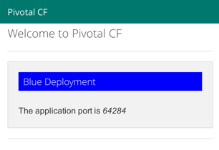

3.     Create additional Route

a.     Use the cf map-route command to create another route to serve as the ‘main’ route for your application.  Example:  **cf map-route blue cfapps.io -n XXX-hotdeploy**, except replace XXX with something unique to your application.

b.     Open a browser and access the app via the new route, i.e.  http://XXX-hotdeploy.cfapps.io, except using the URL based on your subdomain. The application will appear exactly the same in the browser.  Leave this browser window open.

4.     Alter the application

a.     Using any editor you like, open the src/main/resources/templates/index.html page.

b.     Find the tag containing “Blue Deployment”.  Comment this tag out with <!-- à tags.

c.     Notice the tag containing “Green Deployment” that is presently commented out.  Remove the contents.  Save your work.

d.     Execute a “mvn install”: in Eclipse right-click on the project, run as, Maven install.

5.     Deploy a **copy** of the cf_bluegreen application to Cloud Foundry

a.     For this step, you will need to use the CLI.

b.     Give your app the name “green” for the application’s name.  256M should be sufficient.  As always, make sure your deployed URL is unique by customizing the subdomain.

c.     After the application starts, click on the URL to see the application. Notice the large green box on the screen.

6.     Alter Routes

a.     Return to the browser window/tab used in step 3.b.  Refresh it, notice it is still pointing to the old ‘blue’ deployment.

b.     Using the CLI, map the same route that you used in step3.a to the green application.

c.     Alter the blue app by removing this route.

d.     Refresh the browser.  The browser is now pointing to the new green instance with no downtime.

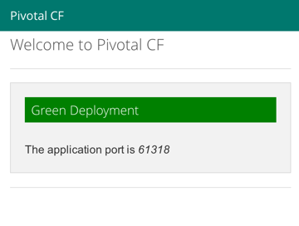

7.     Examine the web console.

a.     Open the Cloud Foundry web console ([http://run.pivotal.io](http://run.pivotal.io/) for Pivotal Web Services).  Sign in with your credentials.

b.     Notice that you have two applications running, one blue, one green. However, only one of these has the “main” route for your application.

c.     Bonus - If you like, use the web console to switch back to the original “blue” application.  You should be able to do this without stopping, starting, or restarting any instances.

d.     Stop both instances.

8.     Congratulations, you have finished this exercise.